SAFe Product Management

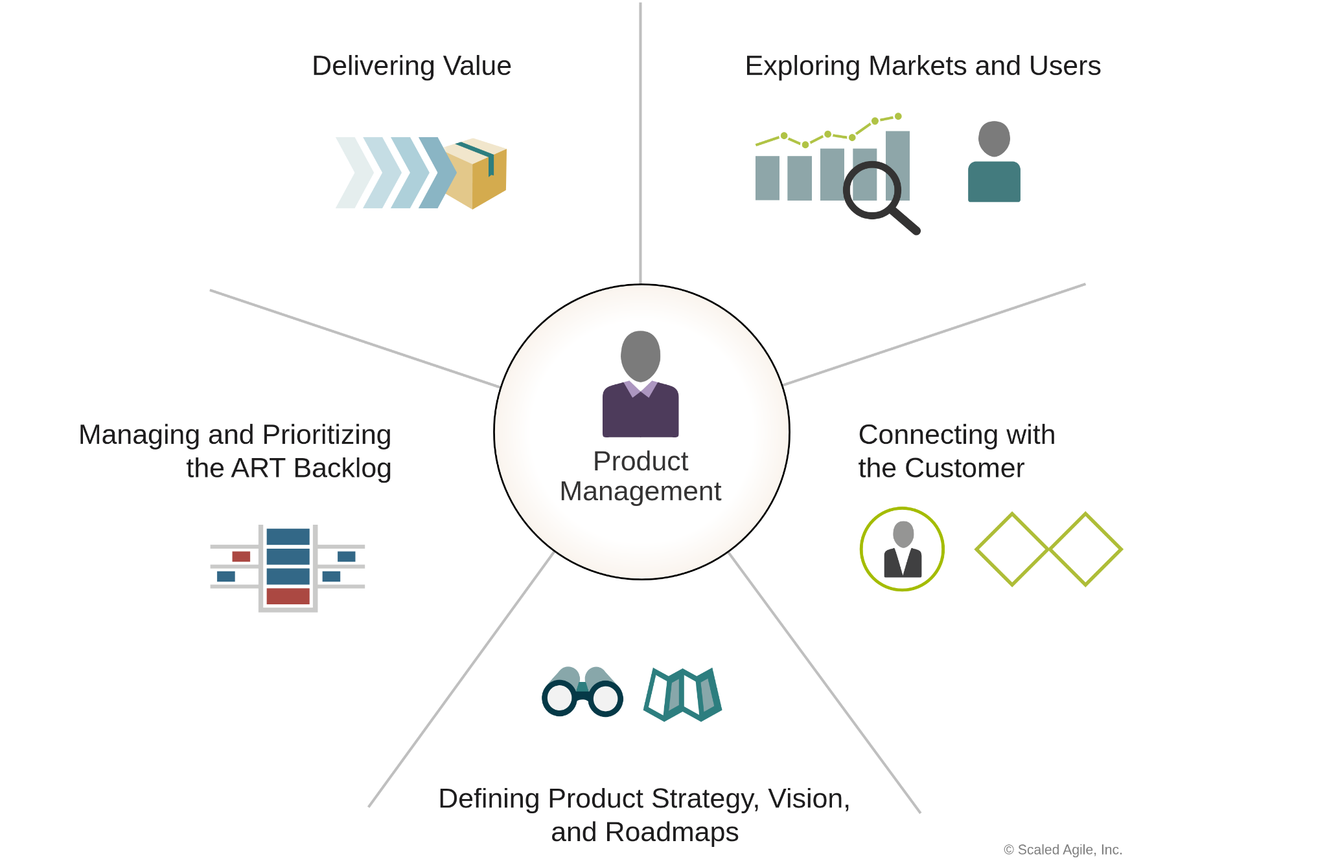

In [SAFe](https://www.google.com/search?q=SAFe&oq=what+is+product+development+lifecylce+in+SAFe&gs_lcrp=EgZjaHJvbWUyBggAEEUYOTIJCAEQIRgKGKABMgkIAhAhGAoYoAEyCQgDECEYChigATIJCAQQIRgKGKABMgkIBRAhGAoYoAEyBwgGECEYjwIyBwgHECEYjwLSAQg4NTg2ajBqN6gCALACAA&sourceid=chrome&ie=UTF-8&mstk=AUtExfBNeuKz7TVxCWMAumlt1YtVwN11vOfFwTGe_SYL44ev44zkJeYc_hh-BEQxLapFzGVIb7w0rbD7-1IVSEOJN2UQKZ58bko2vIFbvaK2wP67H5OFiVrPp7QHqqvijjWR-8QFC1zONYv4F5ACAXV71K2kP1NxLuRKYXY7ClXLBCG0tm3m4-1nKnq8OeQRlCQkEVCfrMWyrsb6ywFlcfNLwXERcKUqdh6TmXJYlhf4j63I_Q-byZu9rxa0nS5t_-VLMhMKSlQyq8R03iE-2RxAiGjA&csui=3&ved=2ahUKEwjj65DJzsaQAxWEvokEHaCvJ0sQgK4QegQIARAD), the product development lifecycle is guided by the [Product Development Flow](https://www.google.com/search?q=Product+Development+Flow&oq=what+is+product+development+lifecylce+in+SAFe&gs_lcrp=EgZjaHJvbWUyBggAEEUYOTIJCAEQIRgKGKABMgkIAhAhGAoYoAEyCQgDECEYChigATIJCAQQIRgKGKABMgkIBRAhGAoYoAEyBwgGECEYjwIyBwgHECEYjwLSAQg4NTg2ajBqN6gCALACAA&sourceid=chrome&ie=UTF-8&mstk=AUtExfBNeuKz7TVxCWMAumlt1YtVwN11vOfFwTGe_SYL44ev44zkJeYc_hh-BEQxLapFzGVIb7w0rbD7-1IVSEOJN2UQKZ58bko2vIFbvaK2wP67H5OFiVrPp7QHqqvijjWR-8QFC1zONYv4F5ACAXV71K2kP1NxLuRKYXY7ClXLBCG0tm3m4-1nKnq8OeQRlCQkEVCfrMWyrsb6ywFlcfNLwXERcKUqdh6TmXJYlhf4j63I_Q-byZu9rxa0nS5t_-VLMhMKSlQyq8R03iE-2RxAiGjA&csui=3&ved=2ahUKEwjj65DJzsaQAxWEvokEHaCvJ0sQgK4QegQIARAE), which is an iterative process focused on delivering value and optimizing economic outcomes. This is achieved through the [SAFe Lean Startup Cycle](https://www.google.com/search?q=SAFe+Lean+Startup+Cycle&oq=what+is+product+development+lifecylce+in+SAFe&gs_lcrp=EgZjaHJvbWUyBggAEEUYOTIJCAEQIRgKGKABMgkIAhAhGAoYoAEyCQgDECEYChigATIJCAQQIRgKGKABMgkIBRAhGAoYoAEyBwgGECEYjwIyBwgHECEYjwLSAQg4NTg2ajBqN6gCALACAA&sourceid=chrome&ie=UTF-8&mstk=AUtExfBNeuKz7TVxCWMAumlt1YtVwN11vOfFwTGe_SYL44ev44zkJeYc_hh-BEQxLapFzGVIb7w0rbD7-1IVSEOJN2UQKZ58bko2vIFbvaK2wP67H5OFiVrPp7QHqqvijjWR-8QFC1zONYv4F5ACAXV71K2kP1NxLuRKYXY7ClXLBCG0tm3m4-1nKnq8OeQRlCQkEVCfrMWyrsb6ywFlcfNLwXERcKUqdh6TmXJYlhf4j63I_Q-byZu9rxa0nS5t_-VLMhMKSlQyq8R03iE-2RxAiGjA&csui=3&ved=2ahUKEwjj65DJzsaQAxWEvokEHaCvJ0sQgK4QegQIARAG), where a Minimum Viable Product (MVP) is built, measured, and learned from to prove or disprove hypotheses, and a continuous development cadence with integrated planning events like [PI Planning](https://www.google.com/search?q=PI+Planning&oq=what+is+product+development+lifecylce+in+SAFe&gs_lcrp=EgZjaHJvbWUyBggAEEUYOTIJCAEQIRgKGKABMgkIAhAhGAoYoAEyCQgDECEYChigATIJCAQQIRgKGKABMgkIBRAhGAoYoAEyBwgGECEYjwIyBwgHECEYjwLSAQg4NTg2ajBqN6gCALACAA&sourceid=chrome&ie=UTF-8&mstk=AUtExfBNeuKz7TVxCWMAumlt1YtVwN11vOfFwTGe_SYL44ev44zkJeYc_hh-BEQxLapFzGVIb7w0rbD7-1IVSEOJN2UQKZ58bko2vIFbvaK2wP67H5OFiVrPp7QHqqvijjWR-8QFC1zONYv4F5ACAXV71K2kP1NxLuRKYXY7ClXLBCG0tm3m4-1nKnq8OeQRlCQkEVCfrMWyrsb6ywFlcfNLwXERcKUqdh6TmXJYlhf4j63I_Q-byZu9rxa0nS5t_-VLMhMKSlQyq8R03iE-2RxAiGjA&csui=3&ved=2ahUKEwjj65DJzsaQAxWEvokEHaCvJ0sQgK4QegQIARAH). The cycle involves ideation, discovery, design, development, and delivery, and includes continuous feedback loops for iteration and improvement.

IDEATION >> DISCOVER >> DESIGN >> DEVELOPMENT >> TESTING >> LAUNCH >> FEEDBACK >> SCALE

**Key components of the SAFe product development lifecycle**

* [Epic Lean-Startup Cycle](https://www.google.com/search?q=Epic+Lean-Startup+Cycle&oq=what+is+product+development+lifecylce+in+SAFe&gs_lcrp=EgZjaHJvbWUyBggAEEUYOTIJCAEQIRgKGKABMgkIAhAhGAoYoAEyCQgDECEYChigATIJCAQQIRgKGKABMgkIBRAhGAoYoAEyBwgGECEYjwIyBwgHECEYjwLSAQg4NTg2ajBqN6gCALACAA&sourceid=chrome&ie=UTF-8&mstk=AUtExfBNeuKz7TVxCWMAumlt1YtVwN11vOfFwTGe_SYL44ev44zkJeYc_hh-BEQxLapFzGVIb7w0rbD7-1IVSEOJN2UQKZ58bko2vIFbvaK2wP67H5OFiVrPp7QHqqvijjWR-8QFC1zONYv4F5ACAXV71K2kP1NxLuRKYXY7ClXLBCG0tm3m4-1nKnq8OeQRlCQkEVCfrMWyrsb6ywFlcfNLwXERcKUqdh6TmXJYlhf4j63I_Q-byZu9rxa0nS5t_-VLMhMKSlQyq8R03iE-2RxAiGjA&csui=3&ved=2ahUKEwjj65DJzsaQAxWEvokEHaCvJ0sQgK4QegQIBBAB): For new products, this cycle focuses on building and evaluating an MVP to prove or disprove a hypothesis before investing heavily.
* [Continuous Exploration](https://www.google.com/search?q=Continuous+Exploration&oq=what+is+product+development+lifecylce+in+SAFe&gs_lcrp=EgZjaHJvbWUyBggAEEUYOTIJCAEQIRgKGKABMgkIAhAhGAoYoAEyCQgDECEYChigATIJCAQQIRgKGKABMgkIBRAhGAoYoAEyBwgGECEYjwIyBwgHECEYjwLSAQg4NTg2ajBqN6gCALACAA&sourceid=chrome&ie=UTF-8&mstk=AUtExfBNeuKz7TVxCWMAumlt1YtVwN11vOfFwTGe_SYL44ev44zkJeYc_hh-BEQxLapFzGVIb7w0rbD7-1IVSEOJN2UQKZ58bko2vIFbvaK2wP67H5OFiVrPp7QHqqvijjWR-8QFC1zONYv4F5ACAXV71K2kP1NxLuRKYXY7ClXLBCG0tm3m4-1nKnq8OeQRlCQkEVCfrMWyrsb6ywFlcfNLwXERcKUqdh6TmXJYlhf4j63I_Q-byZu9rxa0nS5t_-VLMhMKSlQyq8R03iE-2RxAiGjA&csui=3&ved=2ahUKEwjj65DJzsaQAxWEvokEHaCvJ0sQgK4QegQIBBAD): This involves discovering and understanding customer needs, market opportunities, and product opportunities to guide development.
* [Continuous Integration](https://www.google.com/search?q=Continuous+Integration&oq=what+is+product+development+lifecylce+in+SAFe&gs_lcrp=EgZjaHJvbWUyBggAEEUYOTIJCAEQIRgKGKABMgkIAhAhGAoYoAEyCQgDECEYChigATIJCAQQIRgKGKABMgkIBRAhGAoYoAEyBwgGECEYjwIyBwgHECEYjwLSAQg4NTg2ajBqN6gCALACAA&sourceid=chrome&ie=UTF-8&mstk=AUtExfBNeuKz7TVxCWMAumlt1YtVwN11vOfFwTGe_SYL44ev44zkJeYc_hh-BEQxLapFzGVIb7w0rbD7-1IVSEOJN2UQKZ58bko2vIFbvaK2wP67H5OFiVrPp7QHqqvijjWR-8QFC1zONYv4F5ACAXV71K2kP1NxLuRKYXY7ClXLBCG0tm3m4-1nKnq8OeQRlCQkEVCfrMWyrsb6ywFlcfNLwXERcKUqdh6TmXJYlhf4j63I_Q-byZu9rxa0nS5t_-VLMhMKSlQyq8R03iE-2RxAiGjA&csui=3&ved=2ahUKEwjj65DJzsaQAxWEvokEHaCvJ0sQgK4QegQIBBAF): SAFe emphasizes continuous integration of the system and its components to ensure quality and reduce the risk of late-stage integration issues.
* [Continuous Deployment](https://www.google.com/search?q=Continuous+Deployment&oq=what+is+product+development+lifecylce+in+SAFe&gs_lcrp=EgZjaHJvbWUyBggAEEUYOTIJCAEQIRgKGKABMgkIAhAhGAoYoAEyCQgDECEYChigATIJCAQQIRgKGKABMgkIBRAhGAoYoAEyBwgGECEYjwIyBwgHECEYjwLSAQg4NTg2ajBqN6gCALACAA&sourceid=chrome&ie=UTF-8&mstk=AUtExfBNeuKz7TVxCWMAumlt1YtVwN11vOfFwTGe_SYL44ev44zkJeYc_hh-BEQxLapFzGVIb7w0rbD7-1IVSEOJN2UQKZ58bko2vIFbvaK2wP67H5OFiVrPp7QHqqvijjWR-8QFC1zONYv4F5ACAXV71K2kP1NxLuRKYXY7ClXLBCG0tm3m4-1nKnq8OeQRlCQkEVCfrMWyrsb6ywFlcfNLwXERcKUqdh6TmXJYlhf4j63I_Q-byZu9rxa0nS5t_-VLMhMKSlQyq8R03iE-2RxAiGjA&csui=3&ved=2ahUKEwjj65DJzsaQAxWEvokEHaCvJ0sQgK4QegQIBBAH): Products are deployed to production as quickly as possible to get feedback from real users, even if it's a limited release.
* [Continuous Learning](https://www.google.com/search?q=Continuous+Learning&oq=what+is+product+development+lifecylce+in+SAFe&gs_lcrp=EgZjaHJvbWUyBggAEEUYOTIJCAEQIRgKGKABMgkIAhAhGAoYoAEyCQgDECEYChigATIJCAQQIRgKGKABMgkIBRAhGAoYoAEyBwgGECEYjwIyBwgHECEYjwLSAQg4NTg2ajBqN6gCALACAA&sourceid=chrome&ie=UTF-8&mstk=AUtExfBNeuKz7TVxCWMAumlt1YtVwN11vOfFwTGe_SYL44ev44zkJeYc_hh-BEQxLapFzGVIb7w0rbD7-1IVSEOJN2UQKZ58bko2vIFbvaK2wP67H5OFiVrPp7QHqqvijjWR-8QFC1zONYv4F5ACAXV71K2kP1NxLuRKYXY7ClXLBCG0tm3m4-1nKnq8OeQRlCQkEVCfrMWyrsb6ywFlcfNLwXERcKUqdh6TmXJYlhf4j63I_Q-byZu9rxa0nS5t_-VLMhMKSlQyq8R03iE-2RxAiGjA&csui=3&ved=2ahUKEwjj65DJzsaQAxWEvokEHaCvJ0sQgK4QegQIBBAJ): This involves using feedback from users to inform future development, whether through direct user feedback or metrics from the product's performance.
* [PI Planning](https://www.google.com/search?q=PI+Planning&oq=what+is+product+development+lifecylce+in+SAFe&gs_lcrp=EgZjaHJvbWUyBggAEEUYOTIJCAEQIRgKGKABMgkIAhAhGAoYoAEyCQgDECEYChigATIJCAQQIRgKGKABMgkIBRAhGAoYoAEyBwgGECEYjwIyBwgHECEYjwLSAQg4NTg2ajBqN6gCALACAA&sourceid=chrome&ie=UTF-8&mstk=AUtExfBNeuKz7TVxCWMAumlt1YtVwN11vOfFwTGe_SYL44ev44zkJeYc_hh-BEQxLapFzGVIb7w0rbD7-1IVSEOJN2UQKZ58bko2vIFbvaK2wP67H5OFiVrPp7QHqqvijjWR-8QFC1zONYv4F5ACAXV71K2kP1NxLuRKYXY7ClXLBCG0tm3m4-1nKnq8OeQRlCQkEVCfrMWyrsb6ywFlcfNLwXERcKUqdh6TmXJYlhf4j63I_Q-byZu9rxa0nS5t_-VLMhMKSlQyq8R03iE-2RxAiGjA&csui=3&ved=2ahUKEwjj65DJzsaQAxWEvokEHaCvJ0sQgK4QegQIBBAL): This is a crucial event that brings together all teams in an [Agile Release Train](https://www.google.com/search?q=Agile+Release+Train&oq=what+is+product+development+lifecylce+in+SAFe&gs_lcrp=EgZjaHJvbWUyBggAEEUYOTIJCAEQIRgKGKABMgkIAhAhGAoYoAEyCQgDECEYChigATIJCAQQIRgKGKABMgkIBRAhGAoYoAEyBwgGECEYjwIyBwgHECEYjwLSAQg4NTg2ajBqN6gCALACAA&sourceid=chrome&ie=UTF-8&mstk=AUtExfBNeuKz7TVxCWMAumlt1YtVwN11vOfFwTGe_SYL44ev44zkJeYc_hh-BEQxLapFzGVIb7w0rbD7-1IVSEOJN2UQKZ58bko2vIFbvaK2wP67H5OFiVrPp7QHqqvijjWR-8QFC1zONYv4F5ACAXV71K2kP1NxLuRKYXY7ClXLBCG0tm3m4-1nKnq8OeQRlCQkEVCfrMWyrsb6ywFlcfNLwXERcKUqdh6TmXJYlhf4j63I_Q-byZu9rxa0nS5t_-VLMhMKSlQyq8R03iE-2RxAiGjA&csui=3&ved=2ahUKEwjj65DJzsaQAxWEvokEHaCvJ0sQgK4QegQIBBAM) to align on priorities, plan the work for the upcoming Program Increment (PI), and identify dependencies.
* [Built-in Quality](https://www.google.com/search?q=Built-in+Quality&oq=what+is+product+development+lifecylce+in+SAFe&gs_lcrp=EgZjaHJvbWUyBggAEEUYOTIJCAEQIRgKGKABMgkIAhAhGAoYoAEyCQgDECEYChigATIJCAQQIRgKGKABMgkIBRAhGAoYoAEyBwgGECEYjwIyBwgHECEYjwLSAQg4NTg2ajBqN6gCALACAA&sourceid=chrome&ie=UTF-8&mstk=AUtExfBNeuKz7TVxCWMAumlt1YtVwN11vOfFwTGe_SYL44ev44zkJeYc_hh-BEQxLapFzGVIb7w0rbD7-1IVSEOJN2UQKZ58bko2vIFbvaK2wP67H5OFiVrPp7QHqqvijjWR-8QFC1zONYv4F5ACAXV71K2kP1NxLuRKYXY7ClXLBCG0tm3m4-1nKnq8OeQRlCQkEVCfrMWyrsb6ywFlcfNLwXERcKUqdh6TmXJYlhf4j63I_Q-byZu9rxa0nS5t_-VLMhMKSlQyq8R03iE-2RxAiGjA&csui=3&ved=2ahUKEwjj65DJzsaQAxWEvokEHaCvJ0sQgK4QegQIBBAO): SAFe includes practices and built-in quality checks to ensure the product meets the acceptance criteria and quality standards.
* [Customer Centricity](https://www.google.com/search?q=Customer+Centricity&oq=what+is+product+development+lifecylce+in+SAFe&gs_lcrp=EgZjaHJvbWUyBggAEEUYOTIJCAEQIRgKGKABMgkIAhAhGAoYoAEyCQgDECEYChigATIJCAQQIRgKGKABMgkIBRAhGAoYoAEyBwgGECEYjwIyBwgHECEYjwLSAQg4NTg2ajBqN6gCALACAA&sourceid=chrome&ie=UTF-8&mstk=AUtExfBNeuKz7TVxCWMAumlt1YtVwN11vOfFwTGe_SYL44ev44zkJeYc_hh-BEQxLapFzGVIb7w0rbD7-1IVSEOJN2UQKZ58bko2vIFbvaK2wP67H5OFiVrPp7QHqqvijjWR-8QFC1zONYv4F5ACAXV71K2kP1NxLuRKYXY7ClXLBCG0tm3m4-1nKnq8OeQRlCQkEVCfrMWyrsb6ywFlcfNLwXERcKUqdh6TmXJYlhf4j63I_Q-byZu9rxa0nS5t_-VLMhMKSlQyq8R03iE-2RxAiGjA&csui=3&ved=2ahUKEwjj65DJzsaQAxWEvokEHaCvJ0sQgK4QegQIBBAQ): The process is customer-centric, with a strong emphasis on understanding customer needs and incorporating their feedback throughout the development lifecycle.

### Ideation

* 1. Design Thinking => Double Diamond Model
  2. Work with Cross Functional Teams => Align from Research to Release
  3. Execution Methods => Agile & Scrum

**Double Diamond Model**

Double Diamond is a design process model that visually represents four stages—Discover, Define, Develop, and Deliver—to guide teams from problem identification to solution implementation. It uses divergent and convergent thinking to explore a wide range of options before narrowing them down to a final, user-centered solution. This model emphasizes focusing on the right problem before finding a solution, and is not a linear process, but an iterative one.

* **Discover:** This is the first, divergent phase where you research and gather information to deeply understand the problem space and user needs without limitations.
* **Define:** This is the first, convergent phase where you analyze the gathered information to identify patterns and synthesize it into a clear, actionable problem definition.
* **Develop:** This is the second, divergent phase where you brainstorm and create multiple potential solutions to the defined problem.
* **Deliver:** This is the second, convergent phase where you test and refine the most promising solutions, and finally implement the best one for users.

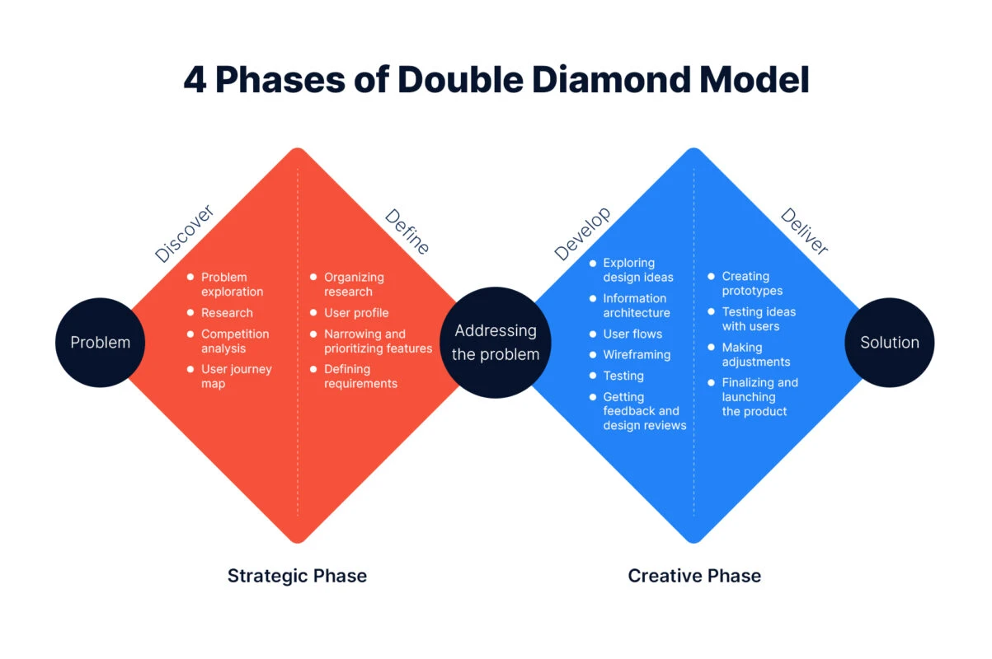

### Product Ideation and Problem Solution Fit

Generating Meaningful Ideas:

* 1. Mind Map
  2. 5 Why Technique
* What is the core problem ?
* Who faces these problems?
* Where do current solution fall short?

**VPC (Value Proposition Canvas) to know the Customer Profile.**

The Value Proposition Canvas is a strategic tool used to ensure a product or service meets customer needs by aligning the company's offering with the customer profile.

It is divided into two main parts: the Customer Profile (which identifies customer jobs, pains, and gains) and the Value Map (which outlines how the company's products, services, pain relievers, and gain creators will address the customer's needs).

By mapping these two sides, businesses can achieve product-market fit and create more effective products and marketing messages.

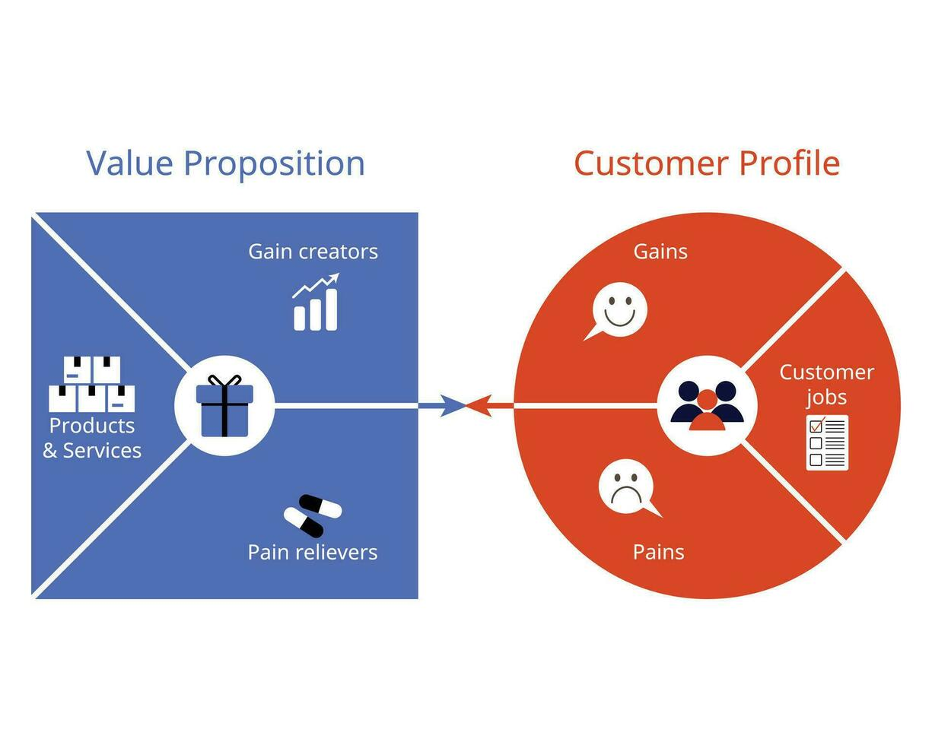

**Customer Profile**

* Customer Jobs: What your customers are trying to accomplish, including functional, social, or emotional tasks.
* Customer Pains: The negative emotions, undesirable costs, and risks customers experience.
* Customer Gains: The benefits, outcomes, and desired results customers expect or desire.

**Value Map**

* Products and Services: A list of all the products and services that could create value.
* Pain Relievers: How your products and services alleviate specific customer pains.
* Gain Creators: How your products and services create customer gains.

### User Research and Persona Development

* User research techniques include -
  + qualitative methods like user interviews, [contextual inquiries](https://www.google.com/search?q=contextual+inquiries&sca_esv=eb5b4f820ac811f1&sxsrf=AE3TifMSpC8LXcbKlfb2AHwENR0B1RezYg%3A1761646105135&ei=GZYAaeSBCKeGptQPuISN8Qc&ved=2ahUKEwjyqvqN1saQAxVUnokEHX9PFK8QgK4QegQIARAC&uact=5&oq=What+are+the+techniques+in+User+Research+and+Persona+Development+%3F&gs_lp=Egxnd3Mtd2l6LXNlcnAiQldoYXQgYXJlIHRoZSB0ZWNobmlxdWVzIGluIFVzZXIgUmVzZWFyY2ggYW5kIFBlcnNvbmEgRGV2ZWxvcG1lbnQgP0iBtwFQAFjBtQFwFHgAkAEBmAH6AaAB9FGqAQczMy40NC45uAEDyAEA-_CQ&sclient=gws-wiz-serp&mstk=AUtExfD_xpAOl0wRNb12l4Wz7NX0BHoW0jMgWy7Yom__SiEYYaSHw-Xc_v5wCt846Scax4uWHW__F86Butay6_WNYJxcrYTUCcnK0ciwrC3_35ldgMEOw-0fVQt9iZr1B9x9JRONbNi7k-7J6tEkyPlHdvByBEs4dwPRqcEm8BZb7dgV54q6nhN-j_x8JeJUV4lG0UbR-Y2os5SjNyWTI2-_JSN8Pq9qFomDtZinVmtio6gY6AkWuwUNJq3SyMNAr8qM6Cx1DdXxZ1jtSh-QWKSNTx2Ouod37yOFePPw6PrF9A5dI3v127-o7Jj7KUM3-PyR6A&csui=3), closed questions, and usability testing.
  + quantitative methods such as surveys, analytics, and A/B testing.
* Persona development uses this research to create fictional user archetypes, and the process involves analyzing data for patterns, defining user segments, and building detailed profiles with goals, pain points, and motivations.

MOM Test is a framework for user research that helps entrepreneurs and product developers get honest, unbiased feedback about their ideas by avoiding "polite lies".

The MOM Test is built on three core rules for conducting customer conversations:

* **Talk about their life, not your idea**: Frame your questions around the user's real-world experiences, problems, and needs, not on validating your product concept.
* **Ask about specifics in the past, not generics or opinions about the future**: Focus on what users have done rather than what they say they might do. Past actions are concrete data, while future hypotheticals are unreliable.
* **Talk less and listen more**: Your goal is to learn, not to sell. Give the user plenty of space to speak without interrupting or projecting your own assumptions.

MOM Test -

1. How they are currently solving the problem.
2. What frustrates them, and what they wish existed.

### Craft the Vision and build a roadmap

Product Roadmap - A visual representation of the product strategic development (WHAT & WHY)

6 Types -

* NOW-NEXT-LATER Roadmap
* Feature Based Roadmap
* Goal Based Roadmap
* Strategy Roadmap
* Release Roadmap

1. Define why the product exists? - Clear Vision and Purpose.
2. Identify who is going to use your Roadmap? - Audience.
3. Gather input and feedback? - Ensure relevant to all of them.
4. Determine the main theme and start creating the Roadmap.
5. Breakdown themes into actionable items.
6. Choose the right Roadmap format.
7. Review and update the Roadmap regularly.

PRODUCT VISION > EPICS > LARGER USER GOALS > USER STORIES

Prioritization Techniques - RICE & MoSCoW

* RICE - Reach, Impact, Confidence, Effort
* MoSCoW - Must Have, Should Have, Could Have, Won’t Have

#### RICE Prioritization Techniques

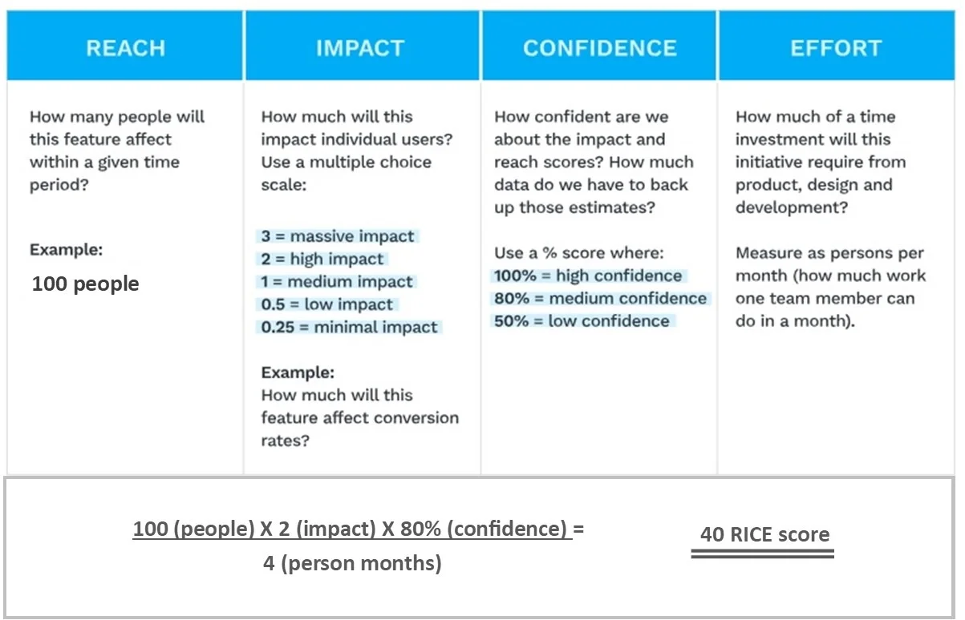

#### MoSCoW Prioritization Techniques

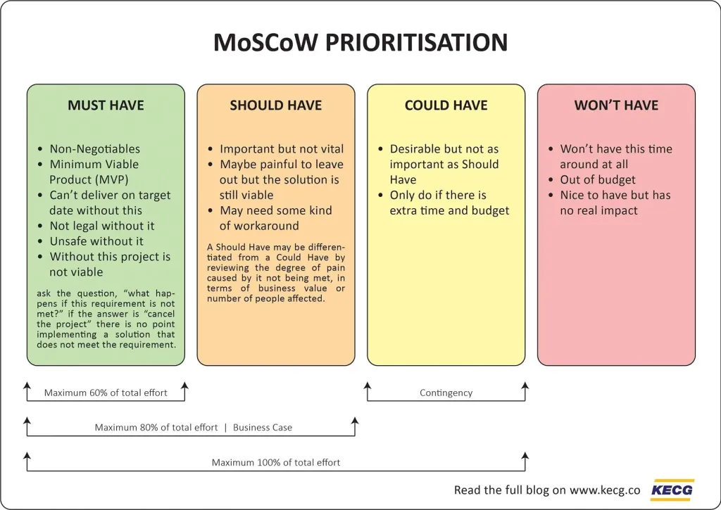

The above techniques help the team to make an objective decision.

MVP —> V1 —> V2 (Map out a flexible roadmap divided into phases).

Roadmaps are not BLUEPRINTS - they are COMPASSES.

Roadmaps evolve with -

* User Feedback
* Technical Feasibility
* Business Priority

### Prototyping, UI/UX Design and Usability Testing

* Create Wireflows with tools life FIGMA.
* Conduct Usability Test with 5-10 users and take feedback on where they hesitate and what confuses them.
* Heuristic Evaluation - Feedback, Visibility, Consistency.
* Develop intuition of how the user thinks and acts.

Tools that help gather feedback efficiently are - MAZE, USABILITY HUB

### Development, Planning and Agile Execution

Break the product into features, and plan through Agile Sprints.

Tools to manage and monitor velocity - JIRA, TRELLO, NOTION

Product Manager - Help resolve dependencies and clarify on requirements (Planning + Execution + Prioritization)

Key Skills: Collaboration + Communication + Adaptability

### MVP Launch and Early Feedback

MVP => 1 Core Job for 1 Targeted User Goal.

Metrics:

* Daily Active Users
* Activation Rate
* Drop of Points
* Net Promoter Score (NPS)

### Iterate based on Data

Listen to data and not opinions in this phase.

Track the user behaviour - Are they using the main features, where are they dropping-off, what is working and what is not working.

Tools used are -

* + Mixpanel
  + Fullstory
  + Google Analytics 4

#### KANO Model

KANO Model is a framework for prioritizing product features based on customer satisfaction and loyalty. It categorizes features into five types: Must-be, Performance, Delighter, Indifferent, and Reverse. This model uses customer surveys to assess how customers feel about a feature's presence or absence, helping companies focus on what truly matters to users.

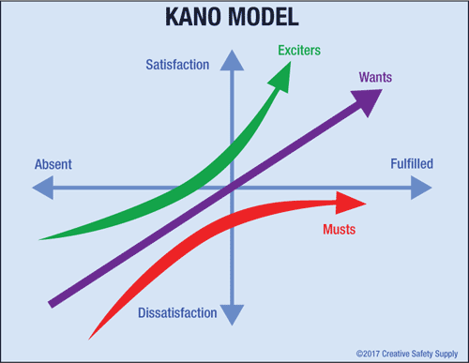

Categories of product features

* **Must-be/Threshold Features**: These are features customers expect and consider essential. A lack of these features leads to dissatisfaction, but their presence is taken for granted.
* **Performance**: The degree of satisfaction for these features is directly proportional to the level of functionality.
* **Delighters/Exciters**: These are unexpected and exciting features that cause a high level of satisfaction. Their absence doesn't cause dissatisfaction, but their presence leads to delight.
* **Indifferent**: Customers have no strong feelings about these features, and their presence or absence does not significantly impact satisfaction.
* **Reverse (or Dissatisfaction)**: These are features that actively cause dissatisfaction. If a feature falls into this category, it should be removed.

How it works

* **Surveys:** The model uses a survey with two questions for each feature: how the customer feels if the feature is present, and how they feel if it is absent.
* **Categorization:** Customers answer each question with one of five options, such as "I like it," "I expect it," or "I dislike it".
* **Analysis:** The answers are used to classify each feature into one of the Kano categories.
* **Prioritization:** This analysis helps product teams prioritize which features to develop. They should focus on Must-be, Performance, and Delighter features, and can either omit or remove Indifferent and Reverse features.

#### Impact vs Effort Matrix

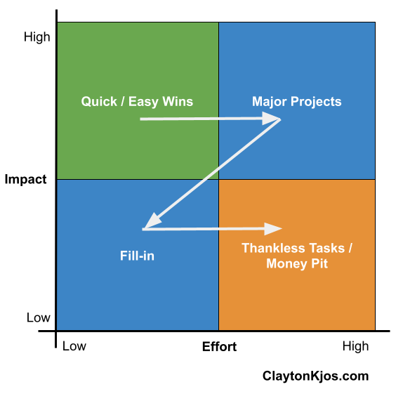

### GTM (Go-to Market) and Branding Strategy

### Post Launch Monitoring and Growth Loopsy

### Case Study and Resume-Ready Portfolio